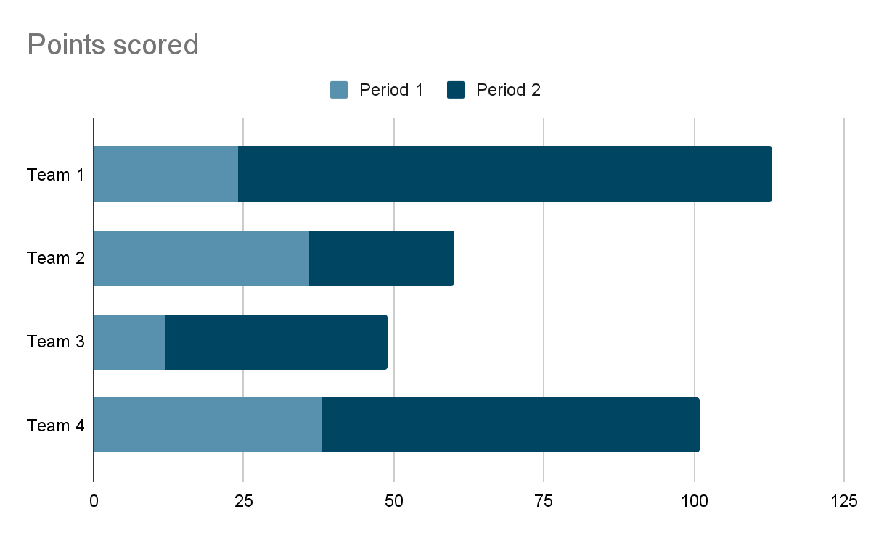

1. **Stacked bar chart:**

* **One-Liner:** Displays parts of a whole in horizontal bars.
* **What:** Segmented bars representing subcategories.
* **Why:** To show both total and individual category contribution.
* **When:** Use when visualizing composition within groups.
* **Where:** In Power BI Visuals.
* **How:** Add category to Axis, and subcategories to Legend

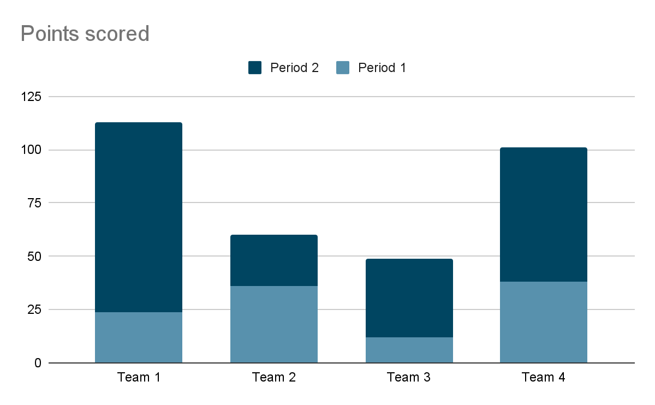  
**2. Stacked column chart:**

* **One-Liner:** Shows total and parts in vertical bars.
* **What:** Vertical bars divided into colored segments.
* **Why:** To compare total values and their breakdown.
* **When:** When both individual and total values matter.
* **Where:** Visualizations pane.
* **How:** Use Axis for main category and Legend for sub-parts.

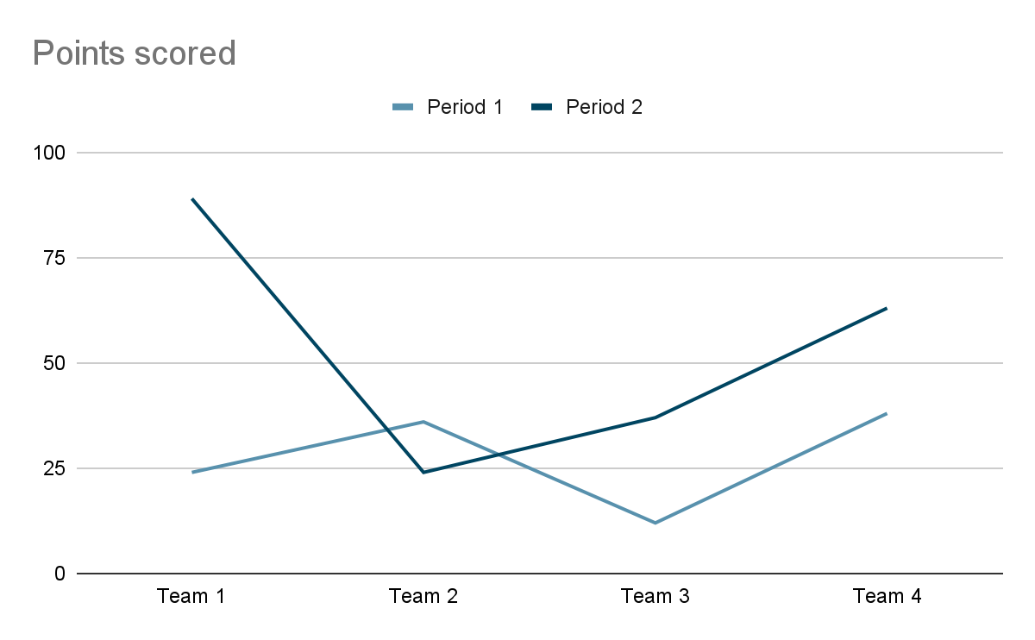

**3. Line chart:**

* **One-Liner:** Used to show trends over time.
* **What:** Data points connected by a line.
* **Why:** For analyzing changes or trends.
* **When:** Best for time series data.
* **Where:** Power BI Desktop visuals.
* **How:** Date on Axis, metric on Values.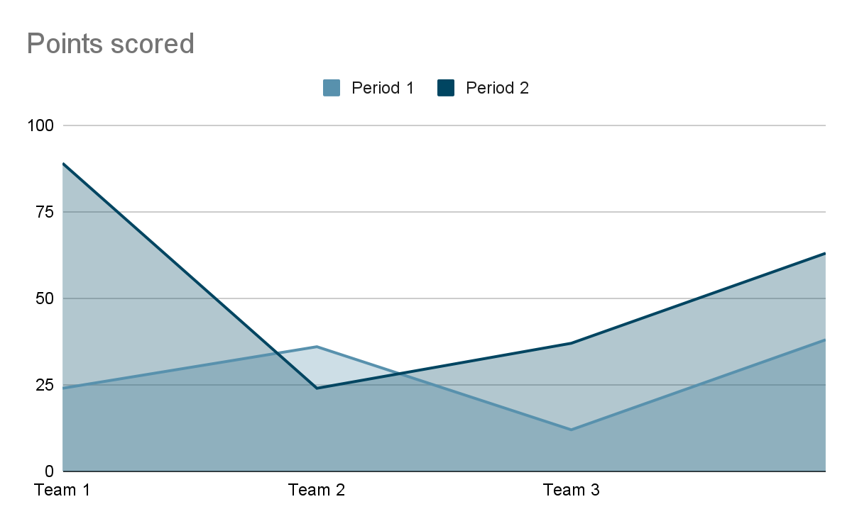

**4. Area chart:**

* **One-Liner:** Line chart with filled color under the line.
* **What:** A line chart with shaded area.
* **Why:** To emphasize volume over time.
* **When:** When visual impact of totals is needed.
* **Where:** Power BI visuals pane.

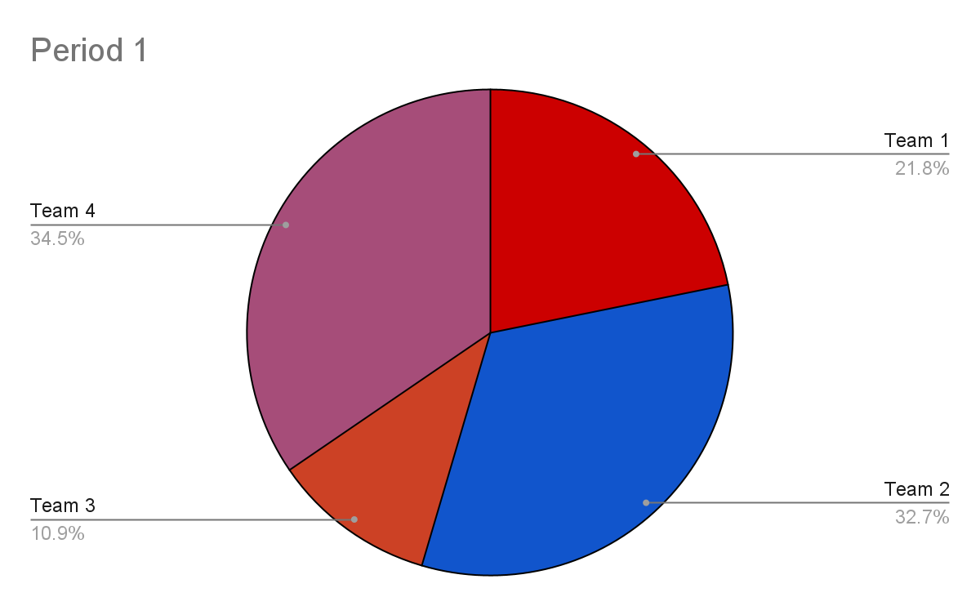

**5. Pie chart:**

* **One-Liner:** Shows proportions of categories.
* **What:** Circle divided into slices.
* **Why:** To represent parts of a whole.
* **When:** When only a few categories exist.
* **Where:** Visualizations pane.
* **How:** Drag category to Legend and value to Values.

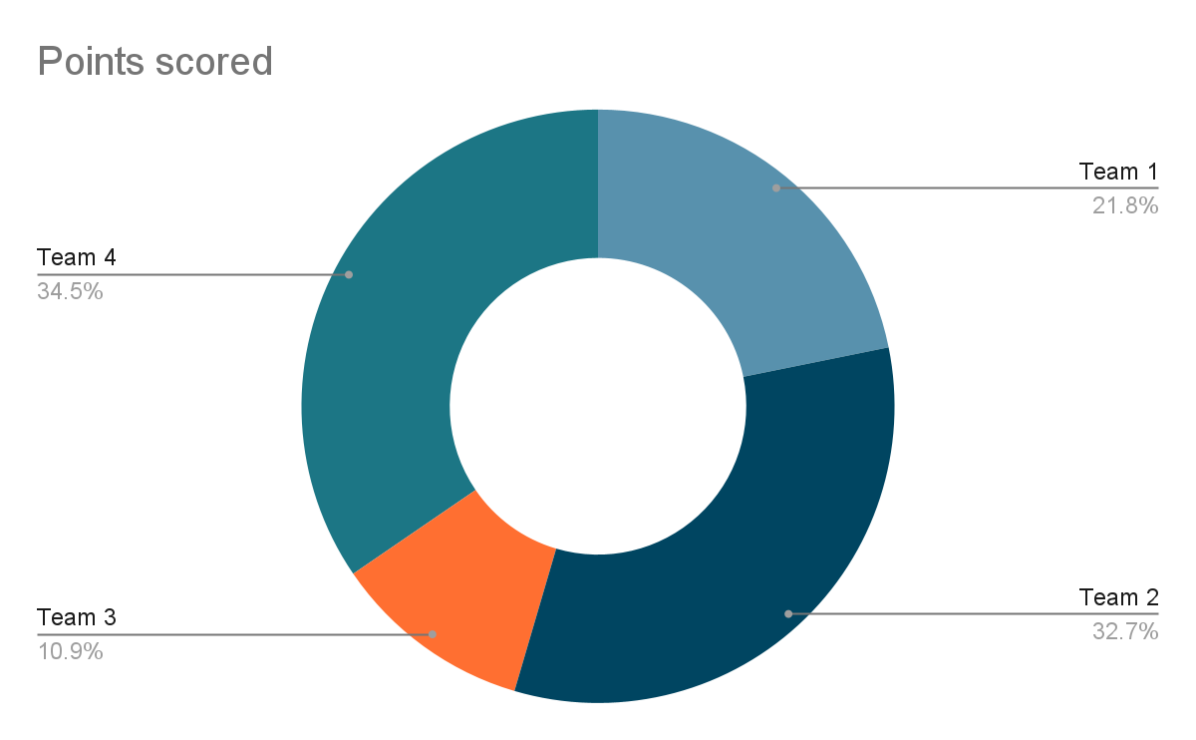

**6. Donut chart:**

* **One-Liner:** Circular chart with a hole, similar to pie chart.
* **What:** Ring-shaped chart.
* **Why:** For a compact, stylish summary.
* **When:** When limited space is available.
* **Where:** In the Visualizations pane.
* **How:** Like Pie Chart setup.

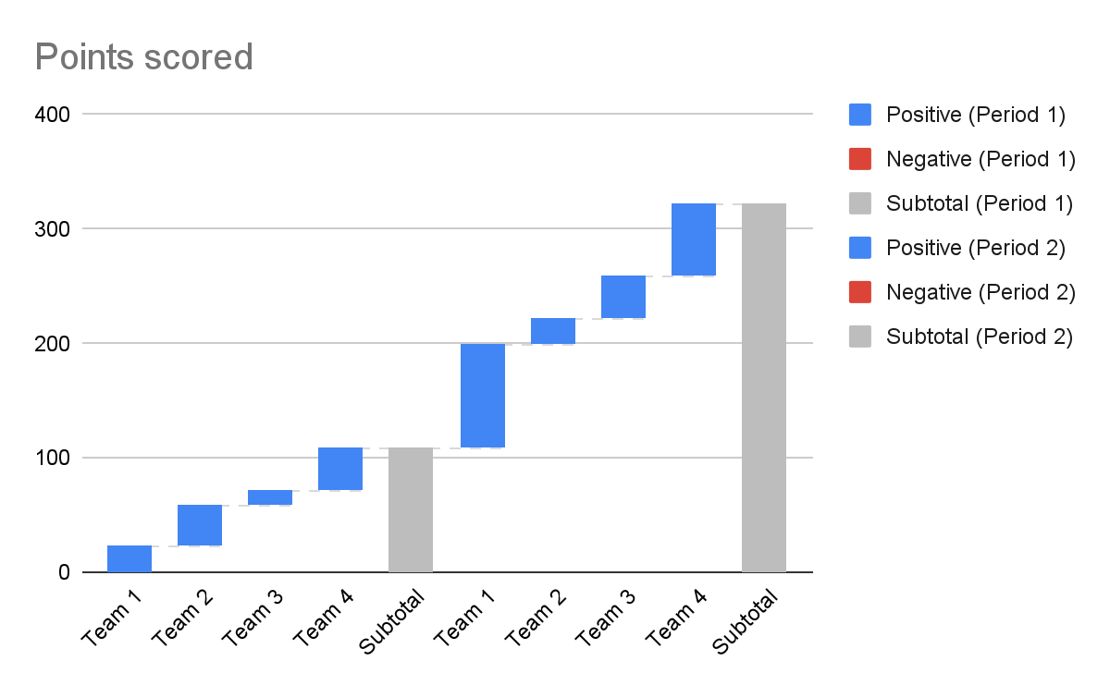

**7. Waterfall chart:**

* **One-Liner:** Shows step-by-step changes in value.
* **What:** Bar chart indicating additions/subtractions.
* **Why:** To visualize contribution to final total.
* **When:** For financial and sales analysis.
* **Where:** Visuals pane.
* **How:** Add category and value fields.

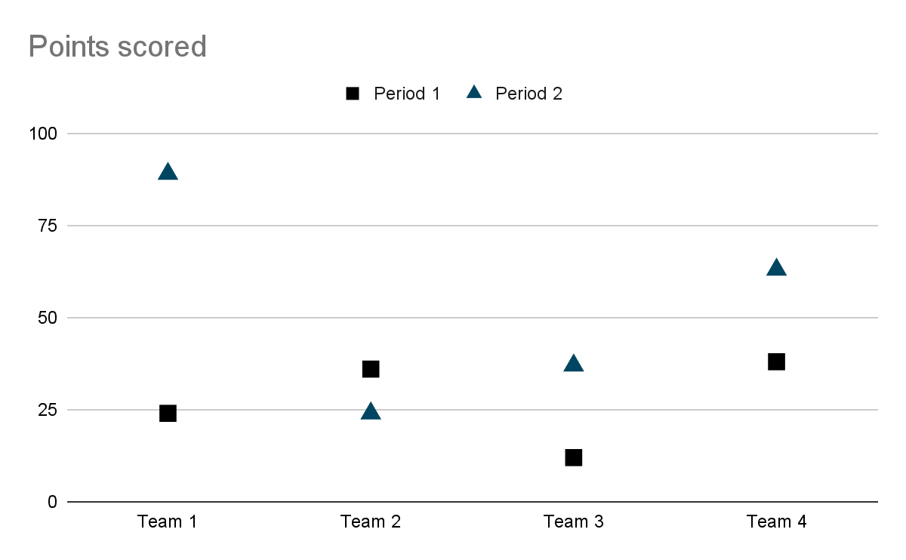

**8. Scatter chart:**

* **One-Liner:** Displays correlation between two numeric fields.
* **What:** Dots plotted using X and Y coordinates.
* **Why:** To explore relationships or clusters.
* **When:** When comparing two measures.
* **Where:** Visuals panel.
* **How:** Use numeric fields for X, Y, and optionally size

**9. Map:**

* **One-Liner:** Plots data based on geographic location.
* **What:** Location-based scatter plot.
* **Why:** To visualize regional data.
* **When:** When geography is a dimension.
* **Where:** Map visual in Power BI.
* **How:** Drag location field and value field.

**10. Funnel chart:**

* **One-Liner:** Visualizes data across stages in a process.
* **What:** Tapered chart representing flow.
* **Why:** To show reduction across steps.
* **When:** Ideal for sales and conversion funnels.
* **Where:** In Power BI Visuals.
* **How:** Use stages on Axis and values on Values.

**11. Filled map:**

* **One-Liner:** Colors areas on map based on values.
* **What:** Region-based shaded map.
* **Why:** For intensity comparison across areas.
* **When:** When viewing distribution density.
* **Where:** Filled Map in Visuals.
* **How:** Use geographic field and values.

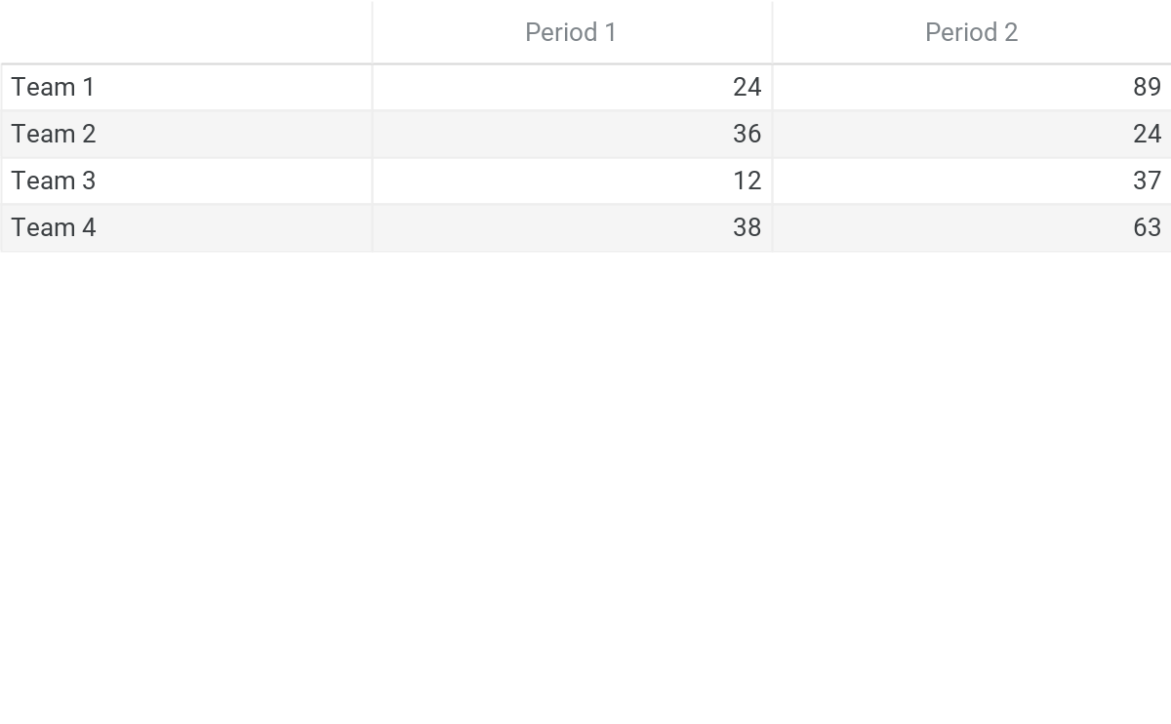

**12. Table**

* **One-Liner:** Shows detailed row-wise data.
* **What:** Grid of raw data.
* **Why:** To display precise values.
* **When:** When detailed reporting is required.
* **Where:** In Power BI Visuals.
* **How:** Drag fields into the table.

**13. Matrix chart:**

* **One-Liner:** Pivot-style summary table.
* **What:** Rows and columns with aggregated values.
* **Why:** For grouped, hierarchical data views.
* **When:** When needing cross-tab analysis.
* **Where:** Power BI Visuals.
* **How:** Use Rows, Columns, and Values fields.

**14. Malti row card:**

* **One-Liner:** Displays multiple values in card layout.
* **What:** Multi-value KPI summary.
* **Why:** For grouped or related KPIs.
* **When:** When showing multiple summaries together.
* **Where:** Visualizations area.
* **How:** Add multiple fields to Values.

**15. Gauge chart:**

* **One-Liner:** Shows a single metric against a goal.
* **What:** Dial-style performance indicator.
* **Why:** For KPI tracking.
* **When:** When comparing actual to target.
* **Where:** Power BI Visual pane.
* **How:** Add Value, Minimum, and Maximum.

**16. Treemap:**

* **One-Liner:** Displays hierarchical data as nested rectangles.
* **What:** Boxed rectangles sized by value.
* **Why:** To show many categories in limited space.
* **When:** When there are too many values for a pie or bar chart.
* **Where:** Power BI Visuals.

**How:** Add category to Group and metric to Values.

**17. Card:**

* **One-Liner:** Displays one big metric value.
* **What:** Single value summary tile.
* **Why:** To highlight a key figure.
* **When:** For dashboard KPIs.
* **Where:** Visuals pane.

**How:** Drag a measure to the card visual.

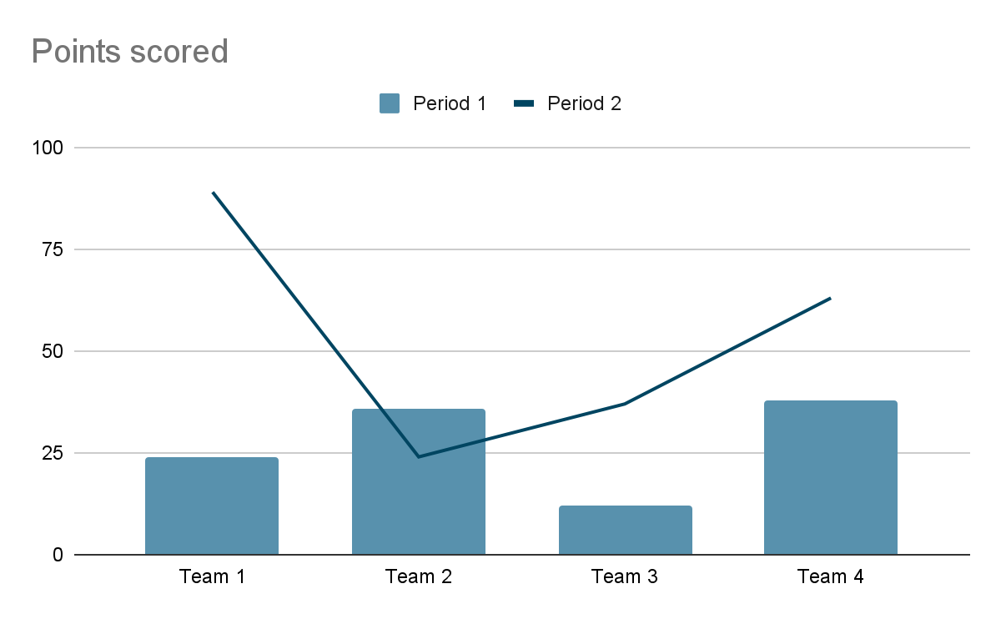  
  
  
**18. Line and stacked column chart:**

* **One-Liner:** Combines column and line chart.
* **What:** Bar and line chart in one.
* **Why:** To compare trends and values.
* **When:** When dual metrics are needed in one chart.
* **Where:** Power BI chart gallery.
* **How:** Set column value and line value separately.

**Q:** What is Power BI?  
 **A:** Power BI is a Microsoft tool for data visualization and business intelligence.

**Q:** Who developed Power BI?  
 **A:** Microsoft.

**Q:** What is Power BI used for?  
 **A:** To transform raw data into interactive reports and dashboards.

**Q:** What are the major components of Power BI?  
 **A:** Power BI Desktop, Power BI Service, and Power BI Mobile.

**Q:** What is Power BI Desktop?  
 **A:** A Windows application to build reports and dashboards.

**Q:** What is Power BI Service?  
 **A:** A cloud-based platform to share and collaborate on Power BI reports.

**Q:** What is Power BI Mobile?  
 **A:** A mobile app to access Power BI dashboards on phones and tablets.

**Q:** What is a dataset in Power BI?  
 **A:** A collection of data used to build reports.

**Q:** What is a report in Power BI?  
 **A:** A multi-page collection of visuals based on a dataset.

**Q:** What is a dashboard in Power BI?  
 **A:** A single-page interactive summary made of visuals pinned from reports.

**Q:** What file extension does Power BI Desktop use?  
 **A:** .pbix.

**Q:** Is Power BI free?  
 **A:** Power BI Desktop is free; the service has free and paid versions.

**Q:** What is the difference between Power BI Pro and Free?  
 **A:** Pro allows sharing and collaboration; Free is for individual use.

**Q:** What is Power BI Gateway?  
 **A:** A bridge to connect on-premises data with Power BI Service.

**Q:** What languages are used in Power BI?  
 **A:** DAX for calculations and M for Power Query transformations.

**Q**: What are filters in Power BI?

**A**: Filters in Power BI are used to refine data displayed in a report by selecting specific values or ranges.

**Q**: What is Power Query?

**A**: Power Query is the data transformation engine in Power BI, used for cleaning, shaping, and preparing data before it's used in visualizations.

**Q**: What is Power Pivot?

**A**: Power Pivot is a data modeling component within Power BI that allows you to create data models from multiple sources.

**Q**: What is DAX?

**A**: DAX stands for Data Analysis Expressions and is the formula language used to create calculated columns and measures in Power BI.

**Q**: What is a slicer?

**A**: A slicer is a visual control that allows users to interactively filter data in Power BI reports.

**Q**: What are custom visuals?

**A**: Custom visuals are specialized visualizations that extend the standard visual library in Power BI.

**Q**: What is a measure?

**A**: A measure in Power BI is a DAX formula that calculates a value based on data in the model.

**Q**: What is a calculated column?

**A**: A calculated column in Power BI is a column added to a table that contains values derived from formulas or expressions.

**Q**: What is the Power BI Service?

**A**: The Power BI Service is the cloud-based platform where Power BI reports and dashboards are published, shared, and accessed.

**Q**: What is the role of the data gateway in Power BI?

**A**: The data gateway acts as a secure connection between Power BI and on-premises data sources, enabling data access for reporting.

**Q:** What are the main components of Power BI?  
 **A:** Power BI Desktop, Power BI Service, and Power BI Mobile.

**Q:** What is a dashboard in Power BI?  
 **A:** A dashboard is a single-page, interactive view of multiple visualizations.

**Q:** What is a report in Power BI?  
 **A:** A report is a multi-page collection of visualizations based on a dataset.

**Q:** What is the use of relationships in Power BI?  
 **A:** Relationships connect different tables to perform cross-table calculations.

**Q:** What is DirectQuery in Power BI?  
 **A:** DirectQuery connects to the data source in real time without importing data.

**Q:** What is the difference between calculated column and measure?  
 **A:** Calculated columns are row-level, while measures are aggregation-level calculations.

**Q:** What is a bar chart used for in Power BI?  
 **A:** To compare categorical data across different groups.

**Q:** What is a line chart used for?  
 **A:** To show trends over time.

**Q:** What is a pie chart best suited for?  
 **A:** To show proportional data or percentage of a whole.

**Q:** When should you use a column chart?  
 **A:** To compare values across vertical bars.

**Q:** What is a stacked bar chart?  
 **A:** A bar chart where data segments are stacked on top of each other.

**Q:** What is a waterfall chart used for?  
 **A:** To show running totals and how values increase or decrease.

**Q:** What does a scatter chart display?  
 **A:** Relationships between two numerical variables.

**Q:** What is a combo chart in Power BI?  
 **A:** A chart that combines column and line visuals.

**Q:** What is a tree map?  
 **A:** A hierarchical chart using nested rectangles to represent parts of a whole.

**Q:** What does a gauge chart show?  
 **A:** A single value compared against a target.

**Q:** What is a funnel chart used for?  
 **A:** To show data flow through stages in a process.

**Q:** What does a map visual display?  
 **A:** Geographic data using locations and values.

**Q:** What is a matrix visual?  
 **A:** A visual like a pivot table with rows, columns, and values.

**Q:** What is the use of a card visual?  
 **A:** To display a single summary value.

**Q: How to merge data in power BI?**

**A:** To merge data in Power BI, use “Merge Queries” in Power Query to combine tables based on a common column.

**Q: How to merge 2 tables into 1 in power BI?**

**A:** To merge 2 tables into 1 in Power BI, go to Power Query > Home > Merge Queries, select both tables and a common column, then choose the join type.

**Q: What is Power Query?**

**A**: Power Query is the data transformation engine in Power BI, used for cleaning, shaping, and preparing data before it's used in visualizations.

**Q: What is DAX?**

**A**: DAX stands for Data Analysis Expressions and is the formula language used to create calculated columns and measures in Power BI.

**Q**: **What is a measure?**

**A**: A measure in Power BI is a DAX formula that calculates a value based on data in the model.

**Q: How to append queries in power BI?**

**A:** In power BI, to append queries, go to POWER QUERY EDITOR - click on “ Append Queries” - choose the tables you want to combine - click ok.

**Q: what is append queries in power BI?**

**A:** append queries in power BI means stacking two or more tables on top of each other to create one combined table.

**Q: what is the different between merge data and append data?**

**A:** marge data combines tables side by side ( add columns ) ,while append stacks tables on top of each other ( add rows ).

**Q: How to remove error in power BI?**

**A:** In power BI, go to Power Query Editor - right click the column with errors - choose “ Remove Errors.”

**Q: How to replace value in power BI?**

**A:** In power BI, go to Power Query Editor - right click the column - select “ Replace Values” - enter the old ( null ) value and new value ( 2024 ).

**Q: what is the use of keep errors in DAX Power BI?**

**A:** Keep errors in power bi is used to show only the rows with errors in a column, so you can check and fix them.

**Q: what is the different between a measure and a calculated column?**

**A:** A measure calculated results dynamically; a calculated column is stored in the table and calculated row-by-row.

**Q: what are power BI visuavlizations?**

**A:** visuavlizations are graphical representations of data, such as charts, graphs, maps etc.

**Q: what is the use of a back button?**

**A:** The back button is a navigation element in apps web browsers that allows users to go back to the previous screen or webpage they were viewing.

**Q: what is the use of buttons in power BI?**

**A:**  change the data that is shown in a chart or table, apply filters to your data, or nevigate between different pages of a report.

**Q: which DAX function is used to calculate running totals?**

**A:** The primary DAX function used to calculate a running total is **CALCULATE** combined with **SUM** and filter based on a date or other sortable column, or the **RUNNINGSUM** function. The **CALCULATE** function allows you to modify the context of the current row and **SUM** calculate the total based on the modified context.

**EXAMPLE: RunningTotal = TOTALYTD(SUM(Sales[Amount]), Dates[Date])**

**Q: what are the two types of DAX?**

**A: Calculated columns:** used to create new columns in a table.

**Example: FullName = Customers[FirstName] & “ “ & Customers[LastName]**

**Measures:** used to calculate totals or summaries like sum,average,etc.

**Example: TotalSales = SUM(Sales[Amount])**

**Q: what is the all keywords in DAX?**

**A: 1. SUM =** Adds Numbers

**2. AVERAGE =** Finds average

**3. COUNT =** Counts rows

**4. IF =** Checks condition

**5. AND / OR =** Logical checks

**6. CALCULATE =** Changes filter context

**7. FILTER =** Filters data

**8. RELATED =** Gets data from related table

**9. ALL =** Returns unique values

**10. VALUES =** Returns unique values

These keywords help create powerful formulas in power BI.

**Q: How do i create a separate table in power BI?**

**A:** 1. Go to the modeling tab.

2. Click on new table.

3. Enter a DAX formula ( example: ProductTable = VALUES(Sales[Product])).

4. Press enter.